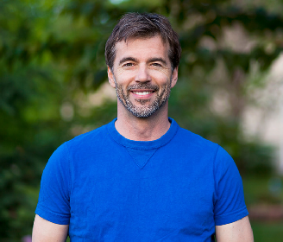J O H N M A T T H E W

**P R E S C H O O L T E A C H E R**

# C A R E E R G O A L S

I create fun and valuable Mathematics, English, and Science lessons for children of

# A C A D E M I C H I S T O R Y

## San Dias University

BA Education | Class Valedictorian  President, Educators Circle

 Vice President, The SDU Official Writers Club

 Member, Mathematics Society  Member, Science Club

 Member, Physics Org

## Pedigon High School

Consistent Honor Student News Writer

 Head Writer, PHS Express

 President, The Pedigon High School Writing Committee

 Head Editor, The PHS Yearbook Committee  Member, The PHS Debate Society

all ages. I aim to teach preschool children in

remote areas.

# C A R E E R H I S T O R Y

**M A I N I N T E R E S T S**

 Entertaining Lesson Plans for Kids  Art in Mathematics

 Literature

 Online Tutoring  Digital Education  Public Speaking

 Spoken Word Poetry

# R E A C H M E A T

## Preschool Teacher

Kyobi Preschool | September 2019 - Present

 Serves as the head teacher for one section

 Teaches art, science, and English to preschool students

 Coordinates with parents for class field trips

## Mathematics Teacher

San Dias Kids Preschool | 2018 - 2019  Taught math to kids aged 3 to 6

 Came up with fun and informative math lessons

for students

 Created new lesson plans for new math teachers

 123-456-7890

 123-456-7890

 [www.techguruplus.com](http://www.techguruplus.com/)  [hello@techguruplus.com](mailto:hello@techguruplus.com)

 123 Anywhere Street, Any City,

State, Country 12345

# A C H I E V E M E N T S

 Best Preschool Teacher (2020)  Most Promising Educator (2019)  Employee of the Year (2018)

 Best Math Teacher (2017)

 Best Faculty Member (2016)